Verbo modal

Can=poder

Yo puedo. Cantar

I can sing

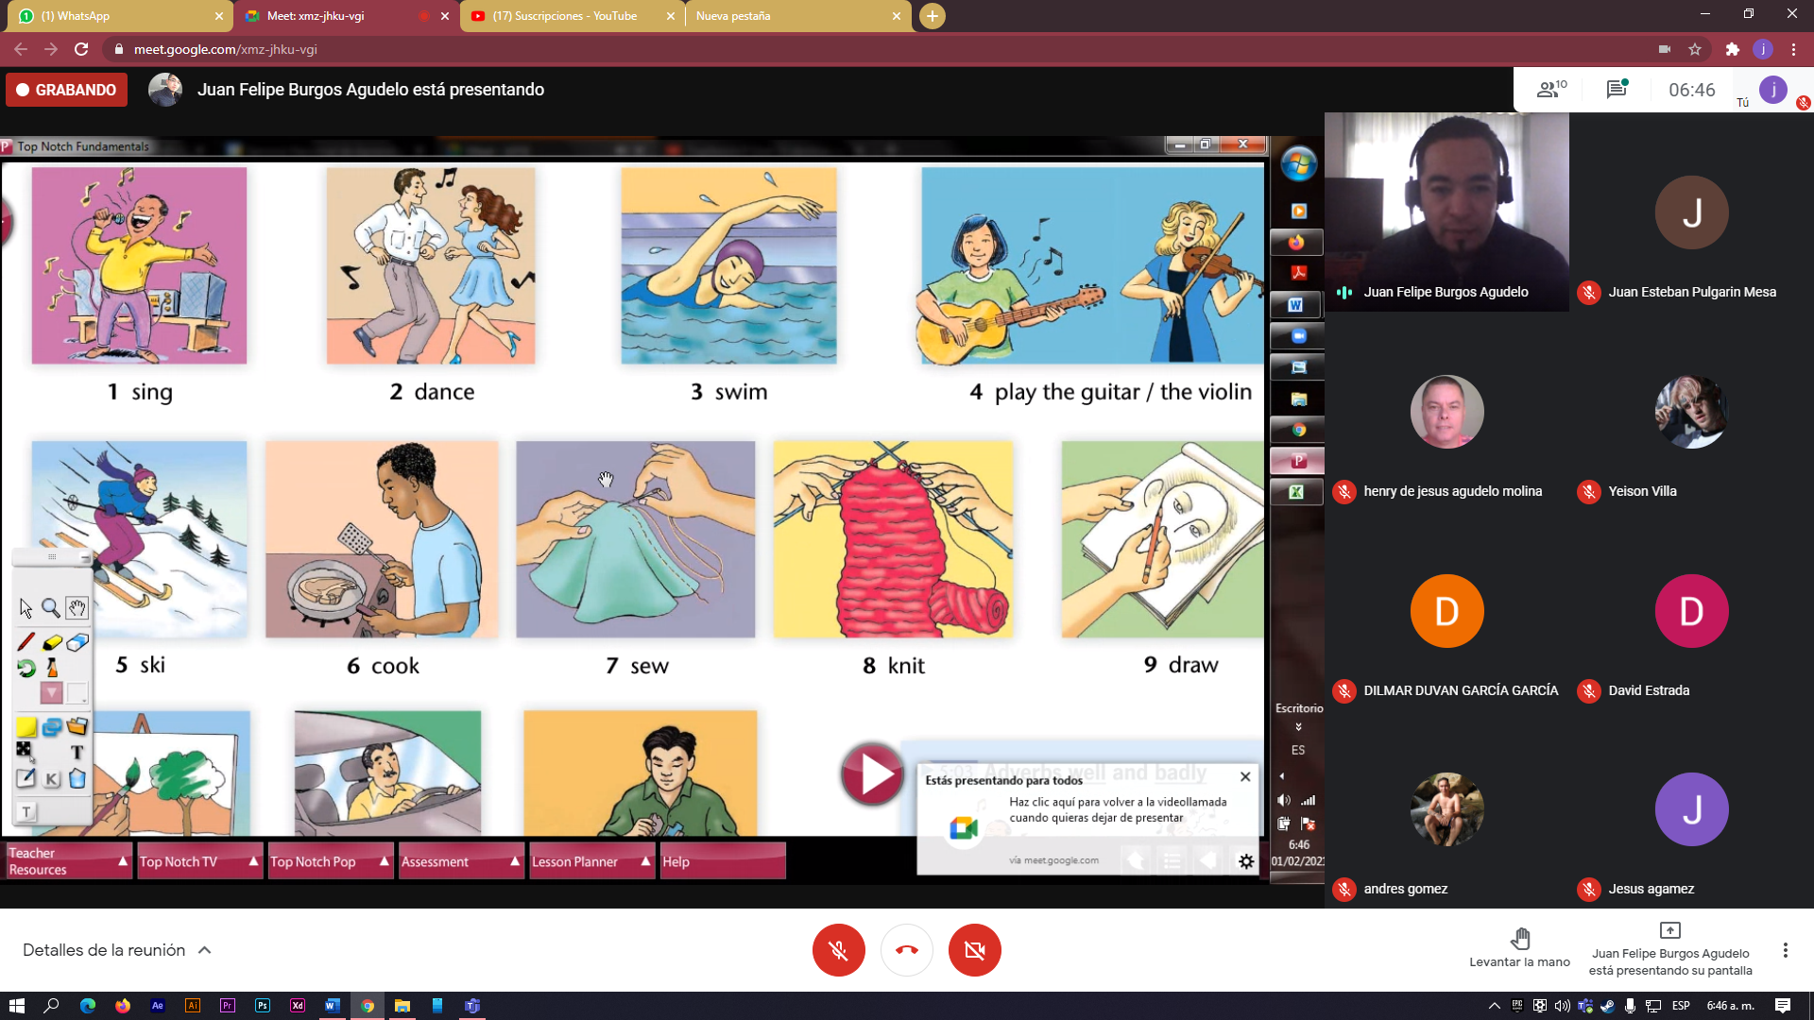

I drive badly

I Paint badly

I can eat badly

I read well

I swin well

I see well

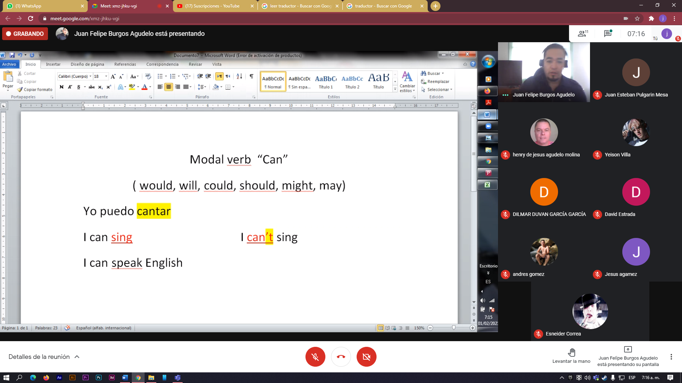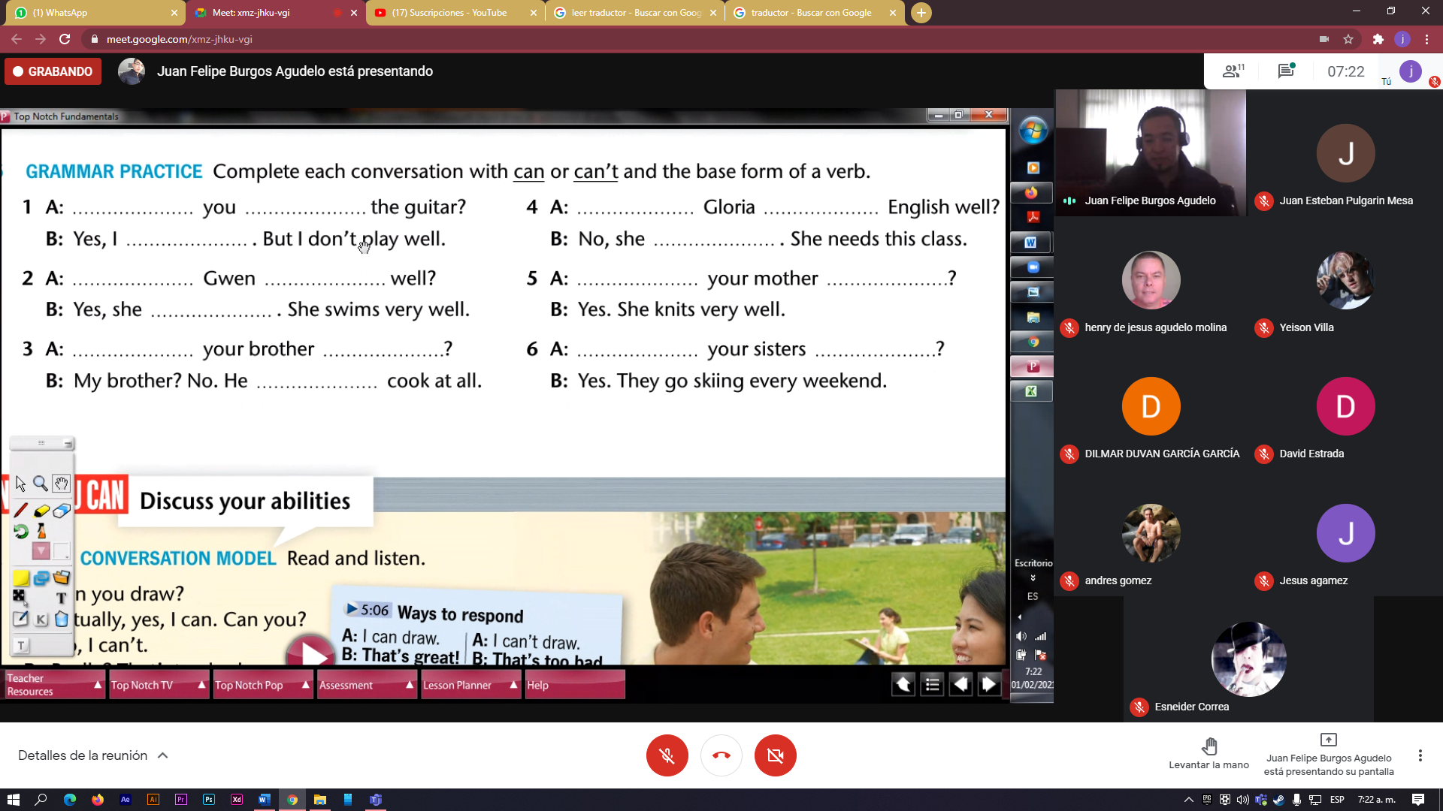

1 A: can you play de the guitar?

B: yess, i can play the guitar. But i don’t play well

2 i can gwen swims well?

Yes,she can,she swims very well

3 can you brother cook well

My brother?no.he can’t cook at well

4 i can gloria speak english well?

No, she can’t,she needs this class

5 can you mother knits?

Yes,she knits very well

6 Can your sisters skiing?

Yess, they go skiing every weekend.